Thermonuclear Fusion Reactors

**Authors: Jessica Kodra, Ina Luckutė**

**Course: Alternative Energy, Past, Present, Future and Innovations**

**Linköping University**

**08/07/2025**

Contents

1.Introduction 3

1.1 Background 3

1.2 Purpose of the Report 3

2. Scientific Principles and Theory 3

2.1 Fusion vs. Fission 3

2.2 Plasma and Fusion Conditions 4

2.3 The Deuterium-Tritium (D-T) Reaction 5

2.4 Reactor Types 5

3. Reactor Components and Operation 7

3.1 Magnetic confinement system 7

3.2 Heating Mechanisms 7

3.3 Fuel Cycle and Tritium Breeding 8

3.4 Energy Extraction and Conversion 8

4. Advantages and Disadvantages 9

5. Significance and Current Developments 10

5.1. Environmental and Energy Impact 10

5.2. Global Energy Strategy Role 10

5.3. Major Ongoing Projects 10

6. Future Innovations and Research Trends 10

6.1 Advanced Reactor Designs 10

6.2 Material Science and Superconductors 11

6.3 AI and Real-Time Plasma Control 11

6.4 Commercialization and Private Sector 11

7. Challenges and Ethical Considerations 11

8. Conclusion 12

9. References 13

# 1.Introduction

## 1.1 Background

Nuclear power is a significant energy resource in the world. The nuclear fission process is currently used in most nuclear power stations whereby large nuclear atoms such as uranium are broken down into small components resulting in the emission of energy. Although good, fission generates radioactive waste that is long term and has safety risks. Another process is nuclear fusion in which the nuclei of light atoms merge to form heavier nuclei while energy is being released. The sun and the stars are fuelled by fusion, and this can offer a clean, safe, nearly inexhaustible energy source on the Earth. But the main problem with this is the controlled use of high temperatures to recreate the fusion conditions.

## 1.2 Purpose of the Report

This report seeks to give a clear concept of thermonuclear fusion as an energy resource. It

addresses the scientific principles and theory of fusion reactors, covering the differences between fusion and fission, the conditions required to recreate fusion and predominant reactor designs that are currently under investigation. By studying these issues, the report presents the advantages and obstacles that fusion might have in shaping the future energy industry.

# 2. Scientific Principles and Theory

## 2.1 Fusion vs. Fission

It is possible to obtain nuclear energy either through splitting heavy atoms (fission) or

merging light atoms (fusion).

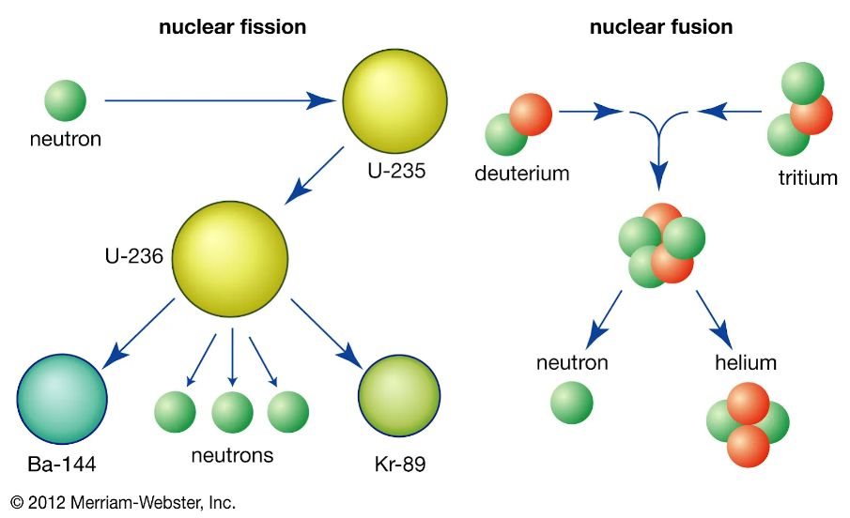

*Figure 1: Fission vs Fusion Diagram*

* Fission divides atoms such as uranium into smaller components and emits energy through the process but creates radioactive waste, which is harmful to life even after thousands of years.
* Fusion involves merging light elements like hydrogen isotopes to make heavier ones like helium, emitting energy that does not result in long term waste. It also generates much more energy in relation to a unit of fuel. Fusion is cleaner, safer, and has a lot harder conditions to create.

## 2.2 Plasma and Fusion Conditions

During fusion, very high temperatures, much higher than 100 million degrees Celsius, are required to cause the collision and fusion of hydrogen atoms. At such high temperatures, matter will be converted into a plasma: a plasma is a gaseous phase in which electrons are ripped off the nuclei, resulting in an ionized gas.

Three conditions must be simultaneously fulfilled to sustain fusion:

* **Temperature**: to give particles enough energy to overcome electrostatic repulsion.
* **Density**: to ensure enough particles collide.
* **Confinement time**: to keep the plasma stable long enough for fusion to occur.

Density × Temperature × Confinement time is formalized in what is known as the Lawson Criterion, which defines the threshold for a fusion reactor to achieve net energy gain. (Lawson Criteria for Nuclear Fusion, 2025)

## 2.3 The Deuterium-Tritium (D-T) Reaction

The most viable fusion reaction to produce energy is deuterium and tritium, which are two heavy versions of hydrogen. During the fusion process, the two combine into a helium atom, a neutron, and produce a lot of energy:

**D + T → He + neutron + energy**

* Deuterium is abundant in seawater.
* Tritium can be bred from lithium inside the reactor.

This reaction is favoured because it requires relatively “lower” temperatures compared to other fusion reactions and yields high energy output.

## 2.4 Reactor Types

There are a number of reactor designs that scientists are pursuing towards maintaining fusion reactions:

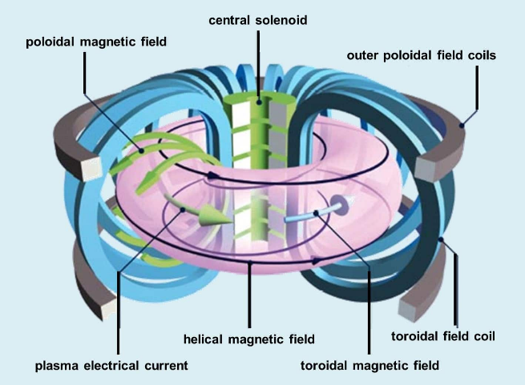

*Figure 2: Tokamak Fusion Reactor Diagram*

**Tokamak**: The most popular design now involves plasma confinement in a doughnut shaped chamber and magnetic fields. (IAEA., n.d.) This is to confine plasma. A powerful electric current heats the plasma and keeps it in control. This design is aimed at demonstrating net energy gain on an international effort based in France called ITER.

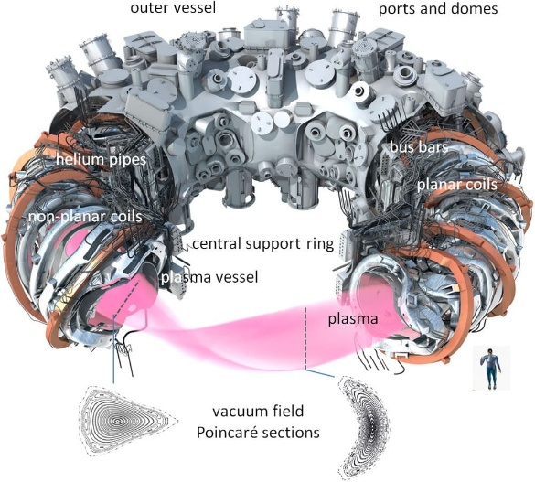

*Figure 3: Stellarator Diagram*

**Stellarator**: Twisted magnetic coils are used to contain the plasma without current in the plasma. Mechanically, it is more complex and provides a more stable, continuous operation. A well-known example is the Wendelstein 7-X in Germany.

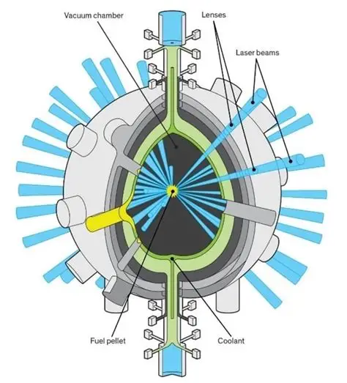

*Figure 4: Inertial Confinement Fusion*

**Inertial Confinement Fusion (ICF)**: involves forcing minute fuel pellets to high densities with lasers or particle beams until fusion is reached in a short time. This is employed in the National Ignition Facility (USA) and plans on ignition over brief and highly intense pulses.

# 3. Reactor Components and Operation

## 3.1 Magnetic confinement system

In a fusion reactor, plasma can reach extreme temperatures of over 150 million °C. No material can withstand these conditions, so strong magnetic fields are used to contain the plasma without making contact with the reactor walls. The magnetic confinement controls the plasma's movement and keeps it suspended in a vacuum to slow heat loss. (Winterton, 1981)

A fusion reactor, such as the tokamak, uses a doughnut-shaped toroidal chamber where the magnetic field is guided and trapped in a closed loop. This system relies on the following two magnetic fields to work together:

·       Toroidal magnetic fields: the field is created by coils surrounding the vessel and wrap the plasma around.

·       Poloidal magnetic fields: these are indued by transformer action, the electric current inside of the plasma generates these fields. These loop around the cross section.

·       Both fields join to form a helical magnetic field to stabilise the plasma.

*Figure 5: Toroidal and Poloidal Diagram*

## 3.2 Heating Mechanisms

For fusion to occur, extremely high temperatures are required to overcome electrostatic repulsion between the positive nuclei. The temperatures required are over 10 times hotter than the core of the Sun. On Earth, we face the challenge of recreating these conditions to allow for continuous and reliable reactions. (iter, n.d.)

**Ohmic Heating**

An electric current is passed through the plasma, creating internal resistance, which is what generates heat. It is effective initially but loses efficiency as the temperature of the plasma rises and the resistance starts to drop. (Nimratbir Kaur, 2017)

**Neutral Beam Injection (NBI)**

High-energy neutral atoms are injected into high-speed plasma. These atoms collide, and the collision causes the neutral atoms to become ionised, confining them in the magnetic field. The collisions transfer energy, heating the plasma.

**Radio Frequency (RF) Heating**

Generates heat using high-frequency electromagnetic waves, which are sent into the reactor. They are sent in waves and are used to match the natural movements of the particles, either ions or electrons, so that they absorb energy from the waves. Absorbing energy causes them to move faster, which is what heats the plasma. (RF Heating, n.d.)

## 3.3 Fuel Cycle and Tritium Breeding

Two kinds of hydrogen isotopes are used to power fusion reactors: deuterium and tritium. Tritium is rare and radioactive. To combat this, it is produced inside the reactor through tritium breeding. In the reactor, both isotopes are made to fuse to create high-energy neutrons and a helium nucleus. This reaction is what releases large amounts of energy. To sustain the reaction, a lithium blanket is used around the plasma chamber. Neutrons collide with the lithium and produce new tritium atoms, allowing the reactor to have a self-sufficient tritium supply. (iter, Tritium Breeding, n.d.)

## 3.4 Energy Extraction and Conversion

Fusion reactions release energy mainly in the form of fast-moving neutrons, which carry around 80% of the energy. Neutrons remain unaffected by magnetic fields, so they can escape the plasma and strike the reactor walls, generating heat. (Fusion energy explained: Powering the future of clean energy, 2025)

**How does energy extraction work in practice?**

**Step 1: Neutron Heating**

* Neutrons escape the plasma and collide with the blanket
* This generates kinetic energy, which is converted into thermal energy
* Some neutrons also react with lithium to breed tritium, which is used as a future fuel source.

**Step 2: Heat Transfer**

* Collisions cause the blanket to overheat, so it is cooled using liquid helium, water, or molten salts.
* They absorb the heat and transport it to a heat exchanger, without any fluid mixing.

**Step 3: Power Conversion**

* The heat exchanger converts thermal energy into high-pressure steam.
* The steam makes a turbine spin, driving a generator that produces electricity.
* Two main thermal cycles can be used:
  + Rankine cycle: Uses steam (as in nuclear/coal plants).
  + Brayton cycle: Uses gas (e.g., helium or CO₂) and can be more efficient. (M. Kovari, 2013)

# 4. Advantages and Disadvantages

|  |  |
| --- | --- |
| Advantages | Disadvantages |
| Rich and Renewable Energy Source: There is a lot of deuterium in seawater, and lithium in the crust of the earth, fusion may end up supplying energy for thousands of years to come.  Low Radioactive Waste: Fusion generates much less long-term radioactive waste as compared to fission. It is mostly radioactive, with most of the radiation being caused by materials around the plasma that were subjected to neutron bombardment that decomposes rapidly.  High energy density: Fusion lets out more energy per kilogram of fuel compared to fossil fuels or fission and correspondingly uses less fuel and has a reduced environmental impact.  Safety: Fusion reactors are not subject to runaway chain reactions and meltdowns, and any loss of control rapidly terminates the reaction. | Technical Complexity: The criteria to maintain high temperature, pressure, and magnetic fields required to achieve fusion is a huge engineering problem. Plasma is imbalanced and hard to manage.  High Costs and long Timelines: Fusion reactors are very costly and rely on a long timeline. Its large projects require decades to construct, and its initial cost is large. It requires precision engineering and very expensive materials.  Material Problems: High energy neutrons caused by fusion erode and make reactor walls brittle. Developing something that can withstand all of this is still in research. |

# 5. Significance and Current Developments

## 5.1. Environmental and Energy Impact

Fusion offers many environmental advantages, especially compared to traditional energy sources

* No greenhouse gases are released during operation, which is great for combating climate change
* The radioactive waste that is produced is minimal and has a short lifespan, which makes it easier to store without concern for long-term safety
* Deuterium is extracted from seawater, which is a highly abundant source, so its supply is essentially unlimited (ITER, 2023)

## 5.2. Global Energy Strategy Role

To combat the climate crisis, the world is transitioning away from traditional fossil fuels to reduce carbon emissions.

* Fusion is seen as a long-term solution to meet demands
* Can provide large-scale and reliable power
* Power generated is carbon-free, important to combat climate change
* Works alongside other renewable sources such as solar and wind energy to ensure future energy security

## 5.3. Major Ongoing Projects

These are a few global projects that are working to make fusion energy practical and reliable in the future.

* ITER: France is developing a tokamak that demonstrates energy gain through magnetic confinement.
* National Ignition Facility (NIF): The U.S. is researching laser-based inertial confinement to initiate fusion.
* EAST tokamak: China is working on plasma duration and temperature.

# 6. Future Innovations and Research Trends

### 6.1 Advanced Reactor Designs

Recent studies are now geared more on creating smaller and efficient fusion reactors using new technologies. For example, small tokamaks with powerful magnets are under development in private companies in the UK, and TAE technologies in the USA. The objective of these designs is to decrease the volume and the expense of reactors without compromising performance. In addition to the reactor design, alternative fuels such as helium-3 and proton-boron are under consideration. The advantage of these fuels is that they produce fewer neutrons thus creating less radioactive waste. But even they need greater temperatures.

6.2 Material Science and Superconductors  
The advancements in material science are the key to successful fusion reactors. There are new radiant resistant materials being developed to improve the lifecycle of reactor parts subjected to heavy neutron bombardment. Moreover, new studies regarding high-temperature superconductivity are allowing the production of stronger magnetic fields that require less extreme cooling. The invention helps to create more compact and efficient reactors and makes them more feasible and cheaper to operate.

## 6.3 AI and Real-Time Plasma Control

An ever-growing role in managing the complex behaviour of plasma in fusion reactors is currently artificial intelligence (AI). Plasma conditions are dynamic and unstable and thus AI systems rely on sensor output to assess plasma conditions in real time. They then rapidly change magnetic fields and heating to stabilize the plasma and sustain fusion reactions. In comparison to conventional methods of control, AI provides a speedier and more accurate reaction and enhances the performance and safety of the reactor. This technology allows solving one of the greatest dilemmas of fusion, as it allows maintaining the stable plasma long enough to generate energy efficiently.

## 6.4 Commercialization and Private Sector

Venture capital and government collaborations with the help of private firms are increasing the speed of fusion development through reducing costs and compressing the timelines. Today companies such as Commonwealth Fusion Systems and Helion Energy are developing prototypes that, potentially within 10-20 years, may create a new sector of commercial reactors.

# 7. Challenges and Ethical Considerations

|  |  |
| --- | --- |
| **Challenges** | **Considerations** |
| **Public Awareness**  The public may have a negative view of nuclear energy, with the general perception being that it is a dangerous and unstable process. This is often based on past global nuclear accidents. | **Safety and Transparency**  It is important to inform the public about safety issues and how radioactive waste is being managed. They must be informed of emergency planning to be ethical, telling them about safety measures and emergency responses that are in place |
| **Constructing New Power Plants**  Thermonuclear plants are multi-billion-dollar infrastructure projects with high capital costs. Stakeholders may be discouraged by the price and the public's disinterest | **Intergenerational Justice**  The way radioactive waste is handled today will affect future generations. Ethical development must consider how the burden will be passed on- it must be handled so that future populations and ecosystems are not endangered. (Schwarz, 2022) |
| **High Operating Costs**  The nuclear industry struggles to compete with traditional energy plants in terms of cost. In the future, new ways to reduce operation and maintenance cost will help make thermonuclear energy more appealing to stakeholders that do not care for the environment**.** (Advantages and Challenges of Nuclear Energy, 2024) |  |

# 8. Conclusion

Thermonuclear fusion has proven to be a highly promising solution to the global diminishing energy supply problem. It comes with few greenhouse gas emissions, the fuel is very abundant, and it produces much less radioactive waste compared to traditional nuclear fission. However, there are still significant barriers that must be overcome. Controlling plasma and maintaining conditions comes with great difficulty; there are very high construction costs, and finding suitable materials to withstand conditions is difficult.

Internationally, there are efforts being made to push these boundaries. Innovations like AI plasma control, advanced superconductors, and compact fusion designs present hope for future advancements to make fusion commercially viable. As the technology develops, ethical considerations are important to consider so that they do not impact future generations, such as with waste responsibility.

Thermonuclear fusion has great potential and will revolutionise the energy landscape in the future. It can become the main strategy for the world's clean energy resources by providing safe, sustainable, and abundant energy for future generations.

# 9. References

*Advantages and Challenges of Nuclear Energy*. (2024, June 11). Retrieved from U.S Department of Energy: https://www.energy.gov/ne/articles/advantages-and-challenges-nuclear-energy

F. Janky, J. H. (2011). Communication Protocol for Plasma Position and Shape Control for the COMPASS Tokamak.

*Fusion energy explained: Powering the future of clean energy*. (2025, May 23). Retrieved from innovationnewsnetwork: https://www.innovationnewsnetwork.com/fusion-energy-explained-powering-the-future-of-clean-energy/58361/

IAEA. (n.d.). *Magnetic Fusion Confinement with Tokamaks and Stellarators*. Retrieved from https://www.iaea.org/bulletin/magnetic-fusion-confinement-with-tokamaks-and-stellarators?utm_source=chatgpt.com

ITER. (2023). *Fusion energy: Clean, safe and virtually limitless*. Retrieved from https://www.iter.org/sci/Fusion

iter. (n.d.). *External Heating Systems*. Retrieved from https://www.iter.org/machine/supporting-systems/external-heating-systems

iter. (n.d.). *Tritium Breeding*. Retrieved from https://www.iter.org/machine/supporting-systems/tritium-breeding

*Lawson Criteria for Nuclear Fusion*. (2025). Retrieved from Gsu.edu.: http://www.hyperphysics.phy-astr.gsu.edu/hbase/NucEne/lawson.html

M. Kovari, C. H. (2013). *Converting energy from fusion into useful forms.* Physics and Society (physics.soc-ph).

Nimratbir Kaur, A. K. (2017). Ohmic Heating : Concept and Application - A Review. *Critical reviews in food science and nutrition*.

*RF Heating*. (n.d.). Retrieved from https://radiofrequency.com/general-industry/rf-heating/

Schwarz, L. (2022). Intergenerational justice starts now: Recognizing future generations in nuclear waste management. *TATuP - Zeitschrift für Technikfolgenabschätzung in Theorie und Praxis / Journal for Technology Assessment in Theory and Practice* , 37-43.

Winterton, R. (1981). Chapter 10- Magnetic Confinement . 163-172.